ES6 and JavaScript

-by Rajneesh Joshi

JavaScript History
The new 6th addition (June 2015) to the JS language is called ECMAScript 6. It is also referred as ES6 or ES2015+. The Standard name is ECMA-262.
The ECMA stands for European Computer Manufacturers Association
ECMAScript is a standard. JavaScript is an implementation of that standard (edition 3 of that standard to be more exact).
Other implementations of ECMAScript are ActionScript and JScript.
Initially JS was the trademark of Netscape. After sometime Netscape got acquired by AOL and Sun, and JavaScript was now owned by Sun. Then Oracle bought Sun.
JS is the trademark of Oracle Corporation
Every browser has a JavaScript interpreter, JavaScript on the server is becoming ever more popular, and now it’s possible to use JavaScript for desktop (Chrome Apps), natives mobile (PhoneGap) and native Windows 8 apps.
An ECMAScript engine is a program that executes source code written in a version of the ECMAScript language standard.
- V8: A JavaScript engine used in Google Chrome, Node.js
- SpiderMonkey: A JavaScript engine in Mozilla Gecko applications, including Firefox.
- Chakra: A JavaScript engine used in Internet Explorer/EDGE.
- JavaScriptCore: A JavaScript interpreter. It is used in the WebKit project and applications such as Safari.
- Nashorn: A JavaScript engine used in Oracle Java Development Kit (JDK) since version 8

This is a brief JavaScript timeline:

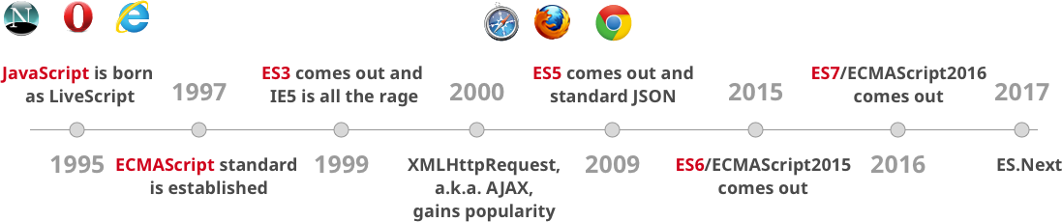

- 1995:
  Brendan Eich, Father of Javascript |   Marc Andreessen, Founder of Netscape
JavaScript was created in 10 days in May 1995 by Brendan Eich, then working at Netscape and now of Mozilla.
The original name was Mocha, a name chosen by Marc Andreessen, founder of Netscape. In September of 1995 the name was changed to LiveScript.
In the end of the same year the name was changed again to JavaScript after receiving the licence from sun.

- 1997: ECMAScript standard is established.
In 1996 - 1997 Netscape passed their JavaScript language to the European Computer. Manufacturers Association (ECMA) for standardisation, which other browser vendors could then implement based on the work done at Netscape.

Official release of ECMA-262 Ed.1: ECMAScript is the name of the official standard.
ActionScript 3 is another well-known implementation of ECMAScript.
- 1999: ES3 comes out.
The standards process continued in cycles, with releases of ECMAScript 2 in 1998 and ECMAScript 3 in 1999, which is the baseline for modern day JavaScript.
- 2000: ES3 comes out with XMLHttpRequest, AJAX.
The "JS2" or "original ES4" work, led by Waldemar Horwat from Netscape.
Microsoft seemed to participate and even implemented some of the proposals in their JScript.net language.
In 2005 Brendan Eich and Mozilla re-joined ECMA as a not-for-profit member and work started on E4X, ECMA-357.
This led to working jointly with Macromedia (later acquired by Adobe), and restarted work on ES4.
- 2009: ES5 comes out (this is what most of us use now) with ‘use strict’, forEach, Object.create, and standard JSON
Adobe released opensource project Tamarin. Tamarin and AS3 were too different from web JavaScript to converge, as was realized by the parties in 2007 and 2008.
Doug Crockford (he introduced the JSON) joined forces with Microsoft in 2007 to oppose ECMAScript 4, which was leading the ECMAScript 3.1 effort. Due to this the development of ECMAScript 4 was never completed.
In between many open source js library has been launched such like Prototype, jQuery, Dojo Toolkit, MooTools
In July 2008, the disparate parties on either side came together in Oslo. This led to the eventual agreement in early 2009 to rename ECMAScript 3.1 to ECMAScript 5 and drive the language forward using an agenda that is known as Harmony. ECMAScript 5 was finally released in December 2009
- 2015: ES6/ECMAScript2015 comes out.
ECMAScript 2015 was released in June 2015

Can we use ES6 now, in modern browsers?
YES! All modern browser and environments support ES6 already!
Chrome, MS Edge, Firefox, Safari, Node and many others have already built-in support for most of the features of JavaScript ES6.
https://kangax.github.io/compat-table/es6/

What will do for old browser?
We need transpiler for JavaScript best known for its ability to turn ES6 (the next version of JavaScript) into code that runs in your browser (or on your server) today. Currently we have two most famous compilers Google’s Traceur and Babel for this purpose.
- Include Traceur in a Web page and it will compile ES6 code on the fly.
- Or use node to compile ES6 to ES5 offline and include the result in Web pages or just run the result in node.
- For babel we have need to setup the environment through node.

Advantages of JavaScript ES6 over ES5

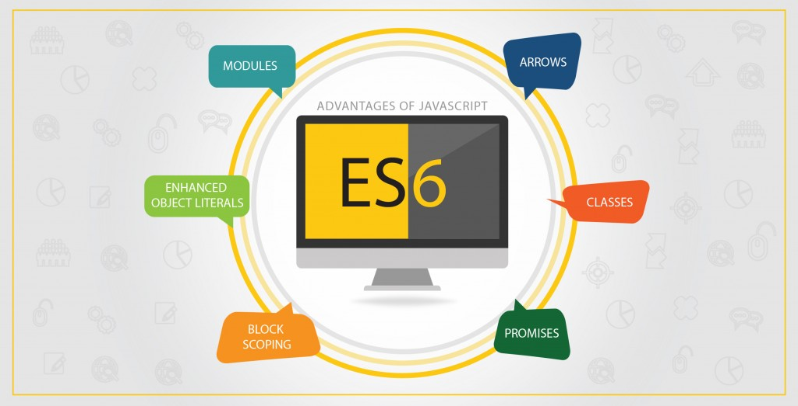

The official goal: A better language for (a) application, (b) library, (c) code generator

ES6 is different because it introduces new syntax, which was a needed transformation/ extension in Javascript. This would definitely help to meet the demands of complex applications written in Javascript. Let us go through the features that has given edge to ES6:
Arrows
Arrows are a function shorthand using the => syntax. There is a similarity between the syntactical features of C#, Java 8, CoffeeScript.

Classes
ES6 classes encourage the prototype-based object oriented pattern and they bring support for inheritance, constructors, static methods and more.

Enhanced Object Literals
Purpose of object literals is to support setting the prototype at construction, shorthand for foo: foo assignments, defining methods, making super calls, and computing property names with expressions.

Modules
In ES6 modules provide a course to load and manage dependencies through the new import export keywords.

ES6 modules are stored in individual files and there can only be one module per file, which still uses the .js file extension.

There are two kinds of exports: named exports (several per module) and default exports (one per module). The most important thing to know is modules can help you clean up your code into easy to maintain chunks and the examples here should help you understand the benefits of easier to maintain code.

Some of the existing JS module systems like AMD(requiredJS) and CommonJS (Node.js used commonJS)

Block Scoping
Scoping becomes an not cleared topic for developers who has background of C/C#/Java. Hoisting can add to that confusion. ES5 lacked a very essential feature of block scoping, which deranked it in comparison to ES6. Though need became the mother of invention and block scoping came into the scenario. ES6 emerged out with this feature, block scoping can be achieved through using let keyword.
Promises
The ES6 is a promising language, where there is an asynchronous operation, there are promises to handle its results and errors. Though callbacks are also designed for the same, but promises provide improved readability via method chaining and succinct error handling. Many JavaScript libraries are using Promises, jQuery. RSVP.js, Q.js, and the $q service in Angular are just a few of many examples.

Core ES6 Features

Let and Const
- The let statement declares a block scope local variable
- You can also use const if you don’t want a variable to change at all.
Example:
https://plnkr.co/edit/J1Pn2HQzOJ3g7pSqF15a?p=preview
https://plnkr.co/edit/1Y0Vzw3uXSLUqAQRmpEs?p=preview

Destructuring
Destructuring is the way of extracting multiple values from data stored in objects and Arrays and reassign them in variable or object. It can be used in locations that receive data (such as the left-hand side of an assignment). We can also destructure the string into characters.
Example:
https://plnkr.co/edit/5yOUWUzG9I71Cl3XMBXR?p=preview

Default parameter
In JS function takes some parameter and JS has ability to pass one, two or n parameters or no parameter. We can define the default value if user not passed any parameter
Example:
https://plnkr.co/edit/fHwTbduKGeXzvabuIoBc?p=preview
Rest parameter and Spread operator
The rest operator is used to get the arguments list passed to function on invocation and in array destructure.
The spread operator is used for array construction and destructuring, and to fill function arguments from an array on invocation
Example:
https://plnkr.co/edit/XGXhH5CsHBrgFLEGmvvs?p=preview

Template Literals
We don’t have to do more nesting concatenations when we have template literals.
Example:
https://plnkr.co/edit/1Xk9Umc0csjpUiUOIJ4y?p=preview

Multiline string
Template Strings are demarked by a backtick(`) on either end and can contain other backticks if they are escaped by a backslash(ie. let myString = `some cool \`escaped\` thing`).
Example:
https://plnkr.co/edit/XupeaYjilTRnaNCvYpBQ?p=preview

Class
In ES5 we fulfil the need of Class by creating “constructor functions”. In ES5, we did Object Oriented programming (OOP) using constructor functions to create objects
In JavaScript every single object has a prototype, which is another object. All JavaScript objects inherit their methods and properties from their prototype.
Example:
https://plnkr.co/edit/7upQ4w33gjsfoR13QiT8?p=preview

Constructor Function
Constructor function is used to initialization logic for an object. It is one of the class member and it is just a function that invokes automatically
Example:
https://plnkr.co/edit/TIHaIsSX7MdT9mTdkpqp?p=preview
Getter and setter
A getter is a method that gets the value of a specific property.
A setter is a method that sets the value of a specific property.
Example:
https://plnkr.co/edit/DiJ4p69s7YCzENs0Xb52?p=preview

Inheritance
Every JavaScript object has a prototype. The prototype is also an object.
All JavaScript objects inherit the properties and methods from their prototype.
Objects created using an object literal, or with new Object(), inherit from a prototype called Object.prototype.
Objects created with new Date() inherit the Date.prototype.
The Object.prototype is on the top of the prototype chain.
Example:
https://plnkr.co/edit/5WR6rWIuVUjCJTylUU9i?p=preview

Super
The super keyword is used to call functions on an object's parent.
Example:
https://plnkr.co/edit/qyMz3oPB9MY39dM22k5M?p=preview

Overrides in Inheritance
Sub Class methods can override the super class methods
Example:
https://plnkr.co/edit/wFea1qCfOEzQGzRqfiSx?p=preview

Arrows
Arrow functions provide two features: lexical scoping of the ‘this’ keyword and less ceremony when defining an anonymous function.
Without arrow functions, every function defines a ‘this’ value.
Example:
https://plnkr.co/edit/63u5m96dG73sKtcLJGi3?p=preview

Iterators
Iterators allows us to define sequences (limited and otherwise) at the language level.
Example:
https://plnkr.co/edit/W0nXiiBHiGfsQ4phRmPn?p=preview

For-of loop
For-of is a new loop in ES6 that replaces both for-in and forEach() and supports the new iteration protocol.
Example:
https://plnkr.co/edit/YZBNTARn2e5JWcYOZLSC?p=preview

Object.is() and Object.assign()
Two new functions has been introduced for objects, Object.is() and Object.assign().Object.is()method determines whether two values are the same value Object.is(value1, value2).
Object.assign() copies the values from one or more source objects to a target object.
Example:
https://plnkr.co/edit/Lz09SqMe9OHVvIGoH64n?p=preview

Object Shorthand
Another syntactic sugar in the upcoming ECMAScript 6 is the object literal property value shorthand.
Example:
https://plnkr.co/edit/nsLUkqTT1RWbwUYd5981?p=preview

Module
In ES6 each module is defined in its own file. The functions or variables defined in a module are not visible outside unless you explicitly export them. This means that you can write code in your module and only export those values which should be accessed by other parts of your app
JavaScript has had modules for a long time. However, they were implemented via libraries, not built into the language. ES6 is the first time that JavaScript has built-in modules.
ES6 modules are stored in files. There is exactly one module per file and one file per module.
Example:
https://plnkr.co/edit/2OORxjZmcR9YTcrnHiKN?p=preview

Multiple named Exports
A module can export multiple things by prefixing its declarations with the keyword export. These exports are distinguished by their names and are called named exports.
Example:
https://plnkr.co/edit/ZPxUE0dDHhHflAKaulJn?p=preview

Default Module
Modules that only export single values are very popular in the Node.js community. But they are also common in frontend development where you often have classes for models and components, with one class per module. An ES6 module can pick a default export, the main exported value. Default exports are especially easy to import.
Example:
https://plnkr.co/edit/VLTpdQ8783S0MMhSOVQ3?p=preview

Simple module using functions instead of classes
https://plnkr.co/edit/dI4KY4usOV4kXC4YBFZO?p=preview

Default module Exports and Re-exporting
https://plnkr.co/edit/LsTWBfZnR4OK40fIra9Q?p=preview

Hiding the details using Symbol
Anyone can change the value of employee name. So to hide and protact the _name object, we use Symbol() to protact the data of the object. Symbol is new buildin type of Js, Every Symbol has value and value is unique and a unique Key
Example:
https://plnkr.co/edit/KH0YS9UMuB5McnVEEeH4?p=preview

Promises
Promises provide a mechanism to handle the results and errors from asynchronous operations. You can accomplish the same thing with callbacks, but promises provide improved readability via method chaining and succinct error handling. Promises are currently used in many JavaScript libraries. RSVP.js, Q.js, and the $q service in Angular are just a few of many examples.
https://plnkr.co/edit/avebzemE85xslHWXo4K1?p=preview

Some useful links:
http://adrianmejia.com/blog/2016/10/19/Overview-of-JavaScript-ES6-features-a-k-a-ECMAScript-6-and-ES2015/#Block-scope-variables
https://www.wintellect.com/5-great-features-in-es6-harmony/
http://exploringjs.com/es6/
http://www.naeemrana.com/javascript/ecmascript-harmony-compile-es6-code-to-es5-using-traceurbabel/

